Learning Management System

DATABASE IMPLEMENTATION

**Prepared by: Daniel Obiero**

**UHD CS3321**

**02/28/2019**

**Table of Contents**

1. Overall Description 4

1.1 Mission Statement 4

1.2 Mission Objectives 4

1.3 Major User Views 5

1.4 Product Functions 6

1.4.1 Login/Logout 6

1.4.2 View/Add/Edit/Delete 6

1.4.3 Create Students/Teachers/Courses/Classes 6

1.4.4 Assign Students/Teachers/Courses 6

1.4.5 Create reports 6

1.5 Use Case Diagram 8

1.6 Entity Relation Model 9

Definitions, acronyms, and abbreviations 10

Current procedure 10

**Revision History**

|  |  |  |  |
| --- | --- | --- | --- |
| **Name** | **Date** | **Reason for Changes** | **Version** |
|  |  |  |  |
|  |  |  |  |

# Overall Description

## Mission Statement

The purpose of the Learning Management Database System (LMDBS) is to maintain data that is used and generated to support the academic participants educational delivery.

## Mission Objectives

The Learning Management Database System (LMDBS) will be a Database system for students, educators and administrators. This document details the requirements of the system based on research of teaching institutions and learning management systems that are currently in the market. This report provides user characteristics and primary functions of the Database system.

Mission Objectives for the Learning Management Database System

* To maintain (enter, update, and delete) data on teachers
* To maintain (enter, update, and delete) data on students
* To maintain (enter, update, and delete) data on courses
* To maintain (enter, update, and delete) data on classes
* To maintain (enter, update, and delete) data on semesters
* To maintain (enter, update, and delete) data on programs
* To track the number of courses assigned to teachers
* To track the number of courses assigned to students
* To track the classes where courses are delivered
* To track the time the courses are delivered
* To track the semester that courses are delivered
* To track the student GPA
* To track the student grades
* To report on student GPA
* To report on student grades
* To report on courses assigned to students
* To report on courses assigned to teachers
* To report on classes hosting courses
* To report on courses offered during a semester
* To report on completion of program courses

## Major User Views

|  |  |  |  |  |
| --- | --- | --- | --- | --- |
| **Data** | **Access Type** | **Administrator** | **Teacher** | **Student** |
| **All Students** | Maintain | x |  |  |
|  | Query | x |  |  |
|  | Report | x |  |  |
| **Single Teacher** | Maintain | x | x |  |
|  | Query | x | x | x |
|  | Report | x | x |  |
| **All Students** | Maintain | x | x |  |
|  | Query | x | x |  |
|  | Report | x | x |  |
| **Single Student** | Maintain | x |  |  |
|  | Query | x | x | x |
|  | Report | x | x | x |
| **All Courses** | Maintain | x |  |  |
|  | Query | x | x |  |
|  | Report | x | x |  |
| **Single Course** | Maintain | x | x | x |
|  | Query | x | x | x |
|  | Report | x | x | x |
| **All Classes** | Maintain | x |  |  |
|  | Query | x | x |  |
|  | Report | x | x |  |
| **Single Class** | Maintain | x | x | x |
|  | Query | x | x | x |
|  | Report | x | x | x |
| **All Course Grades** | Maintain |  | x |  |
|  | Query | x | x |  |
|  | Report | x | x |  |
| **Single Course Grade** | Maintain |  | x |  |
|  | Query | x | x | x |
|  | Report | x | x | x |
| **Class Report** | Maintain | x | x |  |
|  | Query | x | x |  |
|  | Report | x | x |  |
| **Course Grade Report** | Maintain |  | x |  |
|  | Query | x | x | x |
|  | Report | x | x | x |

Table 1.3 Major user views for the LMDBS.

## Product Functions

Participants will log in to the system to gain access to menu functions based on preset user privileges. The product will allow users to enter critical data at the beginning of the semester.

Critical data include:

* Student Information
* Teacher Information
* Administrator Information
* Course Information
* Class Information

### Login/Logout

This function will allow users to access different levels of the system based on their level of privilege. The user will be required to provide a username and password. At the end of user session, they are required to logout of the system. The logout function terminates the user session automatically if left unused for fifteen minutes. The operating system log-out function will be set to lock the computer after one minute of idle time.

### View/Add/Edit/Delete

With appropriate permission, the users will be able to perform these tasks based on user credentials.

### Create Students/Teachers/Courses/Classes

This function will allow the administrator to create new Students/Teachers/Courses into the system for related access. The students will be able to assign themselves the courses pertinent to their programs.

### Assign Students/Teachers/Courses

This function will allow the administrator to assign:

* Courses to Teachers
* Courses to Classes

### Create Reports

The end of semester registration report will include:

* Number of students registered
* Number of teachers registered
* Students registry per course
* Teacher registry per course
* Course time table

## Use Case Diagram

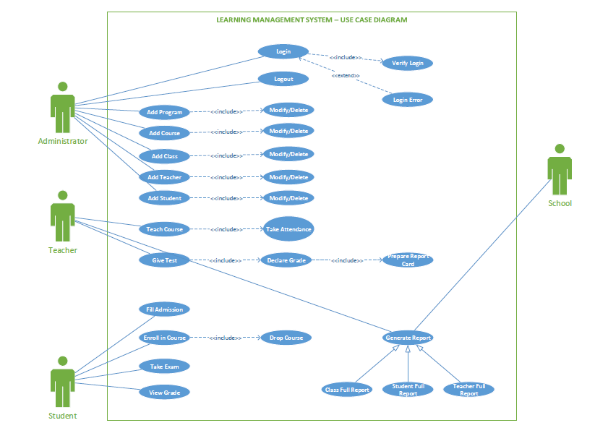

Figure 1.5 Use Case Diagram for LMDBS

## Entity Relation Model

Figure 1.6 Entity-Relationship Diagram of LMDBS

**Appendix A:**

## Definitions, acronyms, and abbreviations

Administrator Radio pharmaceutical isotopes

School Clinics where tests will be performed

Courses Certified Nuclear Medicine Technologist

Class Calculated medical dosage based on isotope decay table

LMDBS Learning Management Database System

System Learning Management Database System

Student Document required to transport the Students from the Management to the clinic

Drop

Add